Unitary matrix

Def

$$U^{⋅}$$ = $$U^{−1}$$

Property

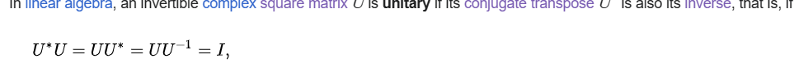

Or



Ref

[Unitary matrix - Wikipedia](https://en.wikipedia.org/wiki/Unitary_matrix)